
QUALITY ALERT

Customer: Solar Date: Sep 04, 2025
Die: 15001-15009-15011-15012 Colour: Any
Type of Complaint: Customer REJECTED

Q.A # 25-045 NCR: N/A RMA#: N/A

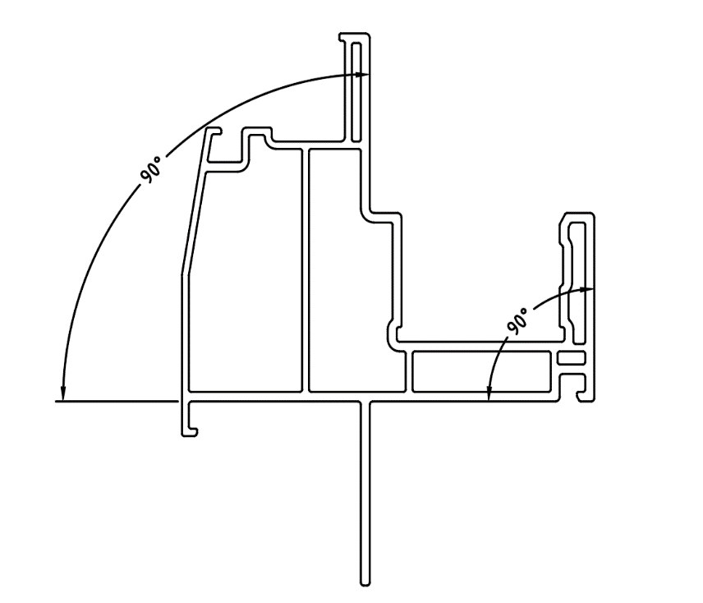
Description: Customer REJECTED due to bottom wall not flat and off square so when inserting into the jig, clamping shifts one or more corners and results in misaligned (off-weld) joints. REPEATED ISSUE!!!
THIS WALL MUST BE FLAT

TOWER MUST BE FLAT AND SQUARE AGAINST BOTTOM WALL

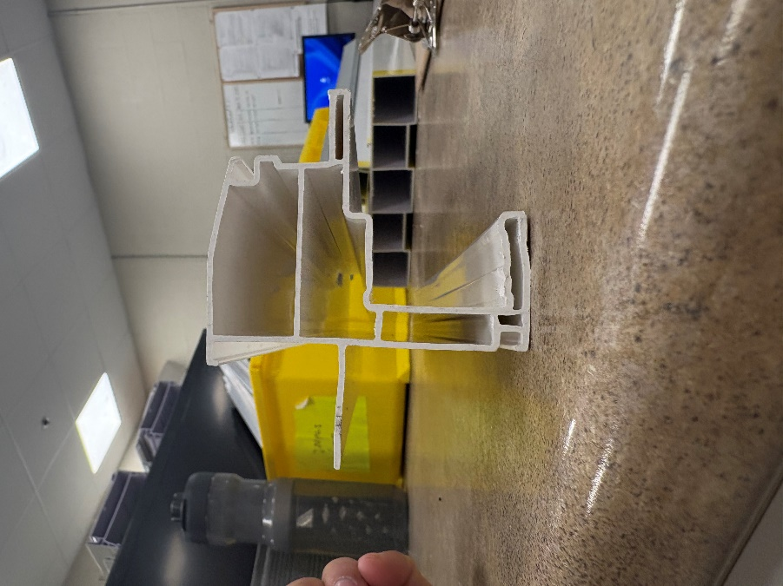



\
ENSURE EXTRUSION IS STRAIGHT, FLAT, AND SQUARE ON AWALLS TO PREVENT MISALIGNMENT DURING CUSTOMER WELDING.

BY SIGNING BELOW, YOU ACKNOWLEDGE THE PROBLEM ABOVE AND AGREE TO MONITOR THIS ISSUE IN FUTURE PRODUCTION RUNS.
DAY SHIFT |  | AFTERNOON SHIFT |  | NIGHT SHIFT
NAME | SIGNATURE | NAME | SIGNATURE | NAME | SIGNATURE

